Boulder Country Club – The Deep End
Boulder, CO

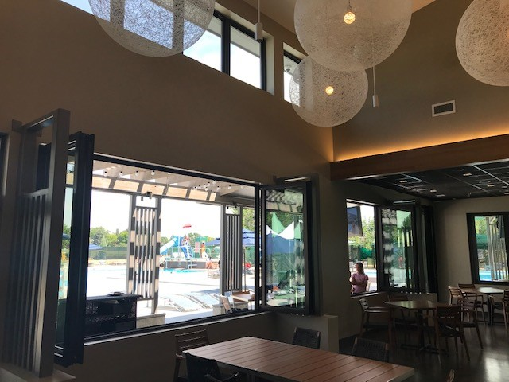
Project Details
Description: 4,000 sf Pool House
Owner: Boulder Country Club
Architect: SopherSparn Architects
CM/GC: Deneuve Construction
Budget: $4.175M
Completion: June 2020

Project Description
The Deep End is a 4,000 sf new poolhouse located at the historic Boulder Country Club in Boulder, CO. The poolhouse includes a bar, full kitchen, men’s and women’s locker rooms and a 1,150 sf dining area. Additionally, the project included construction of 1,100 sf of outdoor dining, sitework and a new playground area with equipment, sunshade and rubber-mat flooring.
Scope of Services
Eric Shafran served as the Principal in Charge, Chris Landry served as Project Executive and Cord Green was the Project Controls Manager for the duration of the design and construction of the Poolhouse and all were charged with overseeing and managing virtually all aspects of the project over a 10-month period. Responsibilities included, but were not limited to:
- Developed and managed the complete project budget, including monthly tracking and reporting of change orders, contingency usage, budget transfers, and commitment levels.
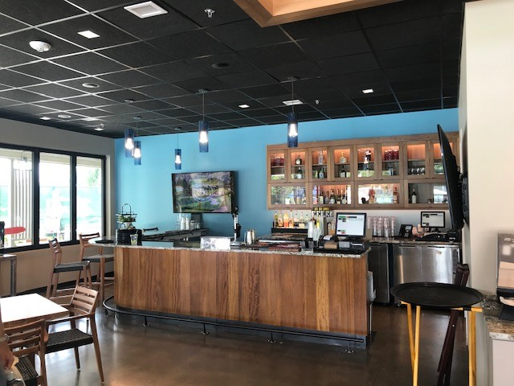
- Coordinated closely with Boulder Country Club staff to minimize disruption to golf operations.
- Supervised the project schedule with strong control over key design, preconstruction, construction, utility, FF&E, and building systems commissioning milestones.
- Oversaw the architectural and interior design teams, ensuring progress toward the Club’s programmatic and aesthetic goals while maintaining construction cost targets.
- Reviewed monthly construction draws and monitored potential and realized change orders daily, leading negotiations as required.
- Prepared detailed monthly reports for the Owner.
- Negotiated, engaged, and managed contracts with secondary consultants in materials testing, surveying, network and security design, audio/visual, and signage design and procurement.
- Directed FF&E selection and procurement, including restaurant- and bar-specific furniture and equipment sourced through multiple vendors and specialty fabricators.
- Coordinated close-out activities with all vendors and consultants.

